Template for Physics of Magnetism’14 Manuscript

A. Author^{a,*}, B. Authorª, C. Author^{b}
ª Institute of Molecular Physics, Polish Academy of Sciences, ul. M. Smoluchowskiego 17, 60-179 Poznań, Poland
^{b} Faculty of Physics, A. Mickiewicz University, ul.Umultowska 85, 61-614 Poznań, Poznań, Poland

Abstract: Insert your abstract here. It should not exceed 200 words.

PACS numbers: in Times New Roman size 10 pt

1. Introduction

This template can be used for estimation of the length of the published manuscript.

2. General information

The Proceedings of the PM’14 Conference will be published as a regular issue of Acta Physica Polonica A. The submission of the paper implies that it represents original work not previously published and not being considered for publication elsewhere.
All contributions submitted will be refereed. It is the right of the Publication Committee to accept or to reject contributions. Please note that each registered participant may submit only one paper for publication in the PM’14 Conference Proceedings.
We welcome suggestions of possible reviewers. To help protect the reviewer's anonymity, we ask for at least four names, with full information on postal and e-mail addresses. The referee selected by the Publication Committee may, of course, not necessarily be from the list.
The maximum length of the article should not exceed 3 printed pages for regular papers and 7 printed pages for invited papers.

3. Manuscript preparation

Word or Open/Libre-Office format and usual types of figures (jpeg, eps, gif, tiff) of the good quality are accepted. The Publication Committee strongly recommends using this template for preparation of the manuscript
Should you prefer not to use the template, please make sure that your manuscript contains all the parts listed below, in correct formatting:
- Title (Times New Roman Capital 18pt, 1.5 line spacing) of no more than 15 words;
- Authors' names with initials (Times New Roman SmalCaps 12pt);
- Authors' affiliations and mailing addresses with designation of corresponding author (Times New Roman 11pt);
- Abstract (Times New Roman 9pt) – not exceeding 200 words;
- Just below the abstract full and up to date PACS Index numbers should be given;
- Main body of the article (TimesNewRoman 10pt);
- References (see http://info.ifpan.edu.pl/APP in section "Guide to authors");
PACS numbers can be found at the following website: http://publish.aps.org/PACS/. The symbols and nomenclature according to the Document IUPAP-25 and SI units are recommended.
Please include, at the end of the file, additionally:
- Mailing and e-mail address of the corresponding author.
- List of captions for figures and tables;
- All figures and tables;
Authors should follow these rules:
- All co-authors of the references should be given (first author only with abbreviation et al. is not acceptable);
- All not commonly known abbreviations should be developed for the first time of their appearance in the text;
- All references, figures and tables must be consecutively numbered and cited in the text. Please give DOI numbers, where applicable.
The detailed info about preparation of manuscript can be found at http://info.ifpan.edu.pl/APP in section "Guide to authors".
The page settings should be following:
- Margins: top 2 cm, left 1.8 cm, right 1.3 cm, bottom 4 cm;
- Two columns: width 8.6 cm, spacing between 0.7 cm;
- One full-filed column contains 58 rows of plain text.
The oversized manuscripts will be rejected.

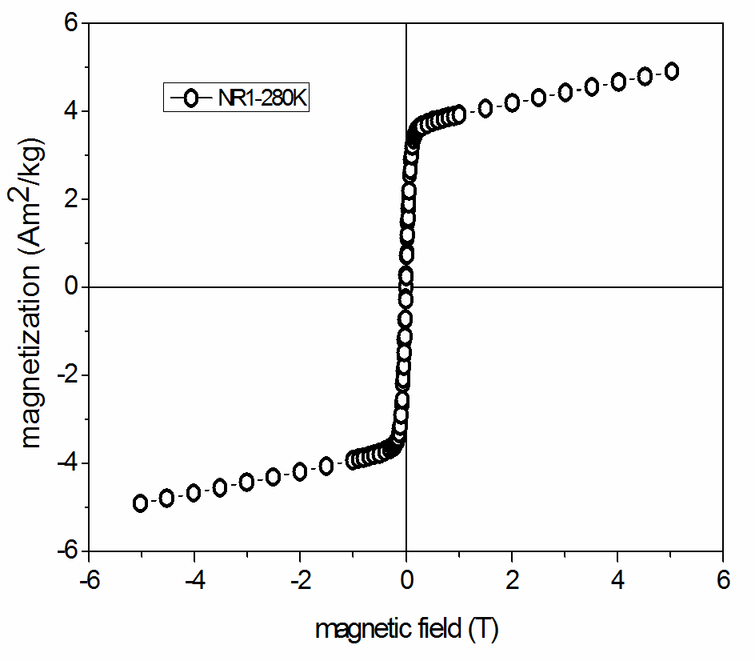Fig.1. Figure caption (TimesNewRoman 9pt)

- Submitting the manuscript

Manuscripts prepared using this template should be submitted before deadline to the Publication Committee of the PM’14 by e-mail (pm14-papers@fizyka.amu.edu.pl ) as .doc or .odt file. The .pdf file and source files for the figures should also be included. If you wish to submit your figures as bitmap files (.jpg, .png, etc.) make sure they are of sufficient resolution (300dpi of higher). Post deadline papers will be rejected.
We recommend combining all your files into a single archive using compression or archiving program prior to sending. Utilities like RAR or WinZIP will both archive and compress your files.

4. Conclusions

If you have any additional questions concerning the preparation of manuscripts please contact the Publication Committee (pm14-papers@fizyka.amu.edu.pl ).

Acknowledgement

This work was supported by the project ……..

References
(see http://info.ifpan.edu.pl/APP in section "Guide to authors")

For a paper in journal:
[1] A. Engelko, H. Bluhm, J. Appl. Phys. 95, 5828 (2004).
DOI:............
For an article in a book:
[2] R. Hirota, in: Solitons, DOI:............ Eds. R.K. Bul-
lough, P.J. Caudrey, Springer, Berlin 1980, p. 157.
For a book:
[3] P.G. de Gennes, J. Prost, The Physics of Liquid Crys-
tals, DOI:............ Oxford Sci. Pub., Oxford 1993.
For an unpublished paper:
[4] L. Gondek, Ph.D. Thesis DOI:............, Jagiellonian
University, Kraków 2004.

